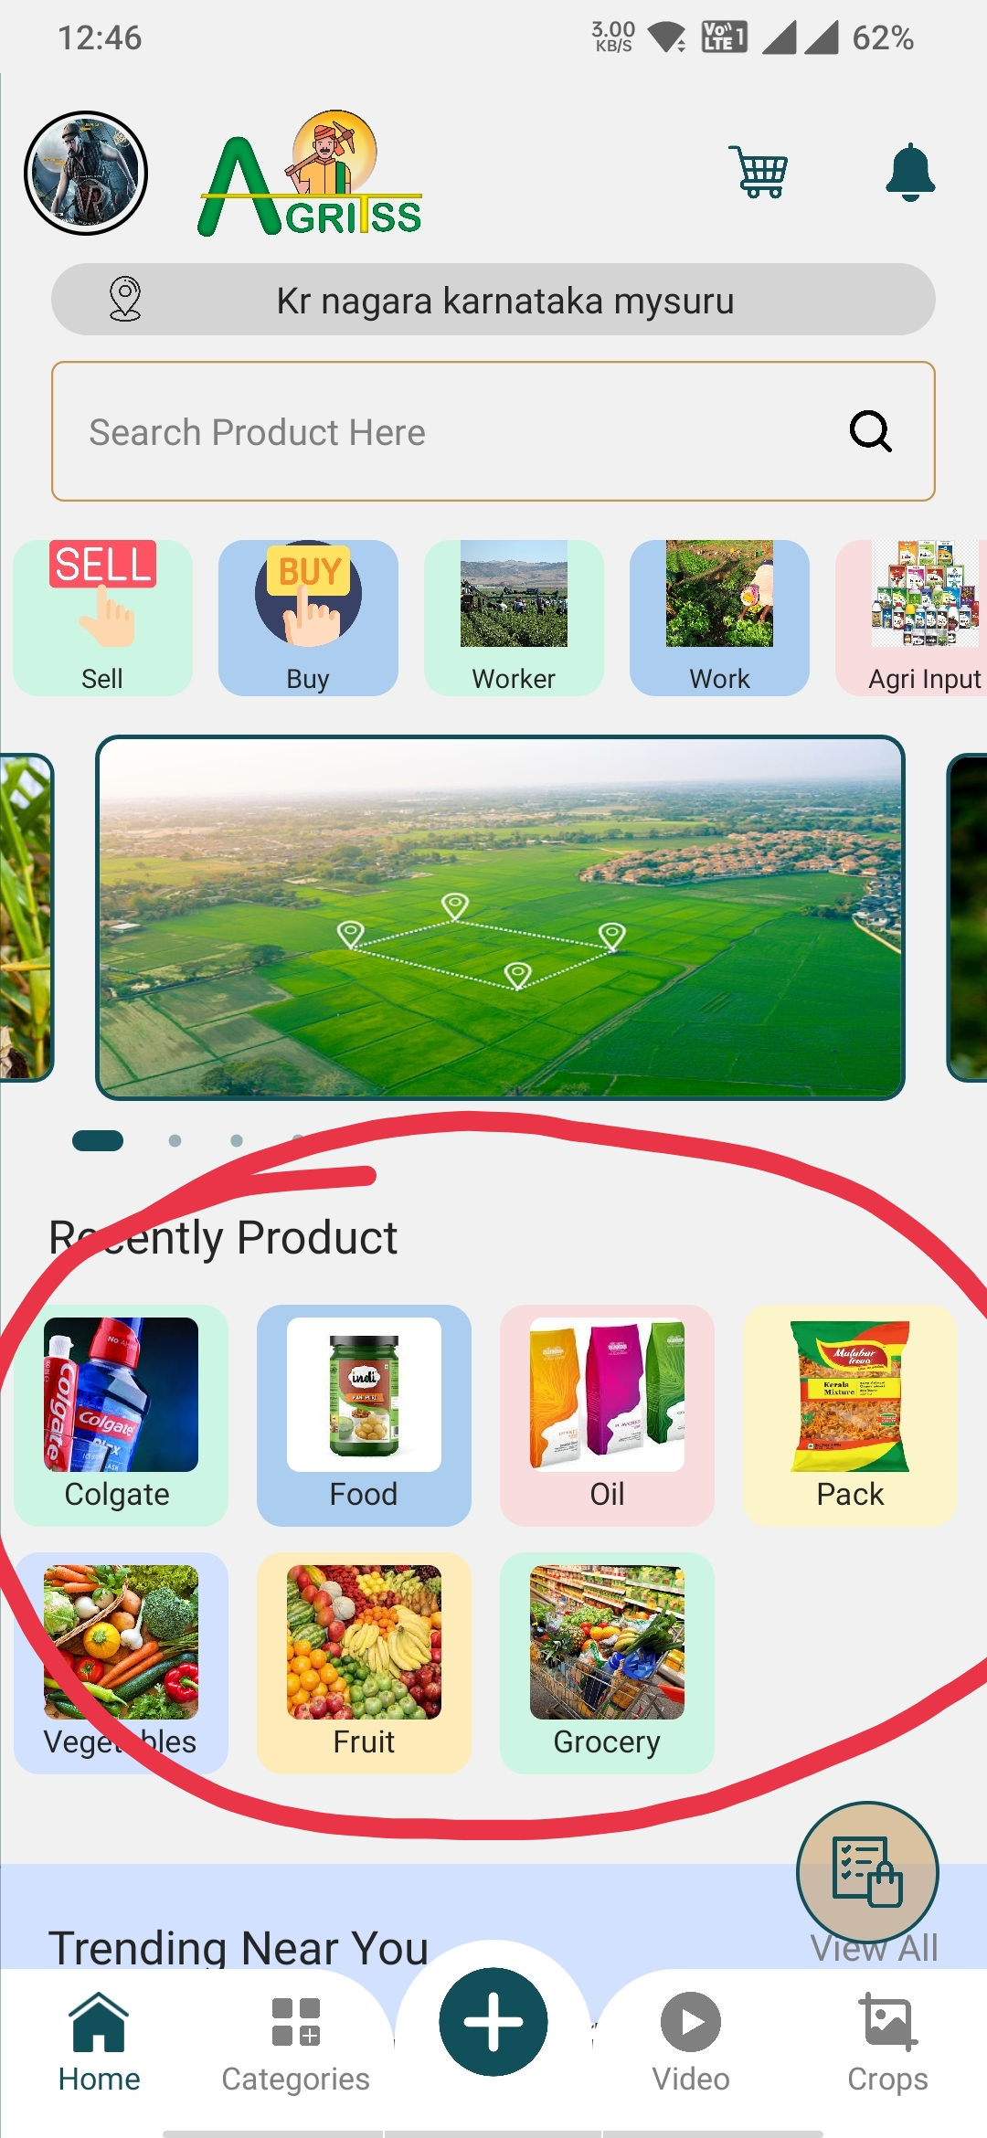

The home page should be categories, inside the categories the admin should be able to add products.

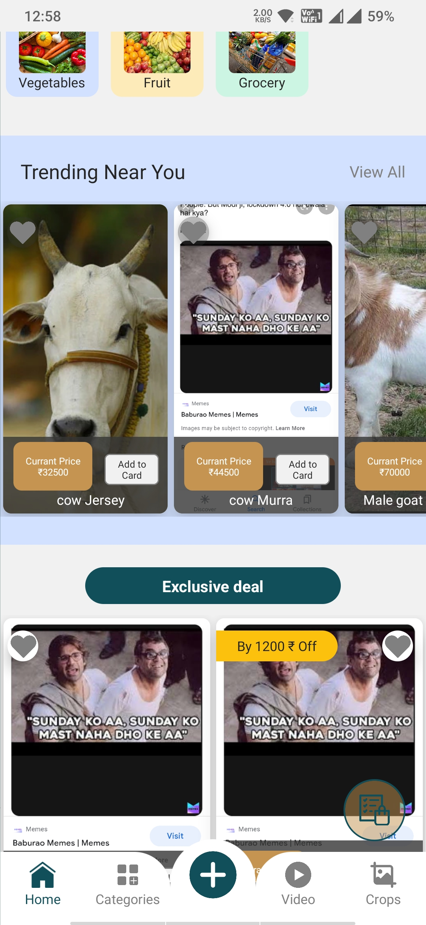

Trending near you and exclusive deal is for the admin part only not for the categories where users will be uploading things. These options is not for user uploaded things admin only should have permission to add products into exclusive deal and trending near you.

Just add descriptions for land.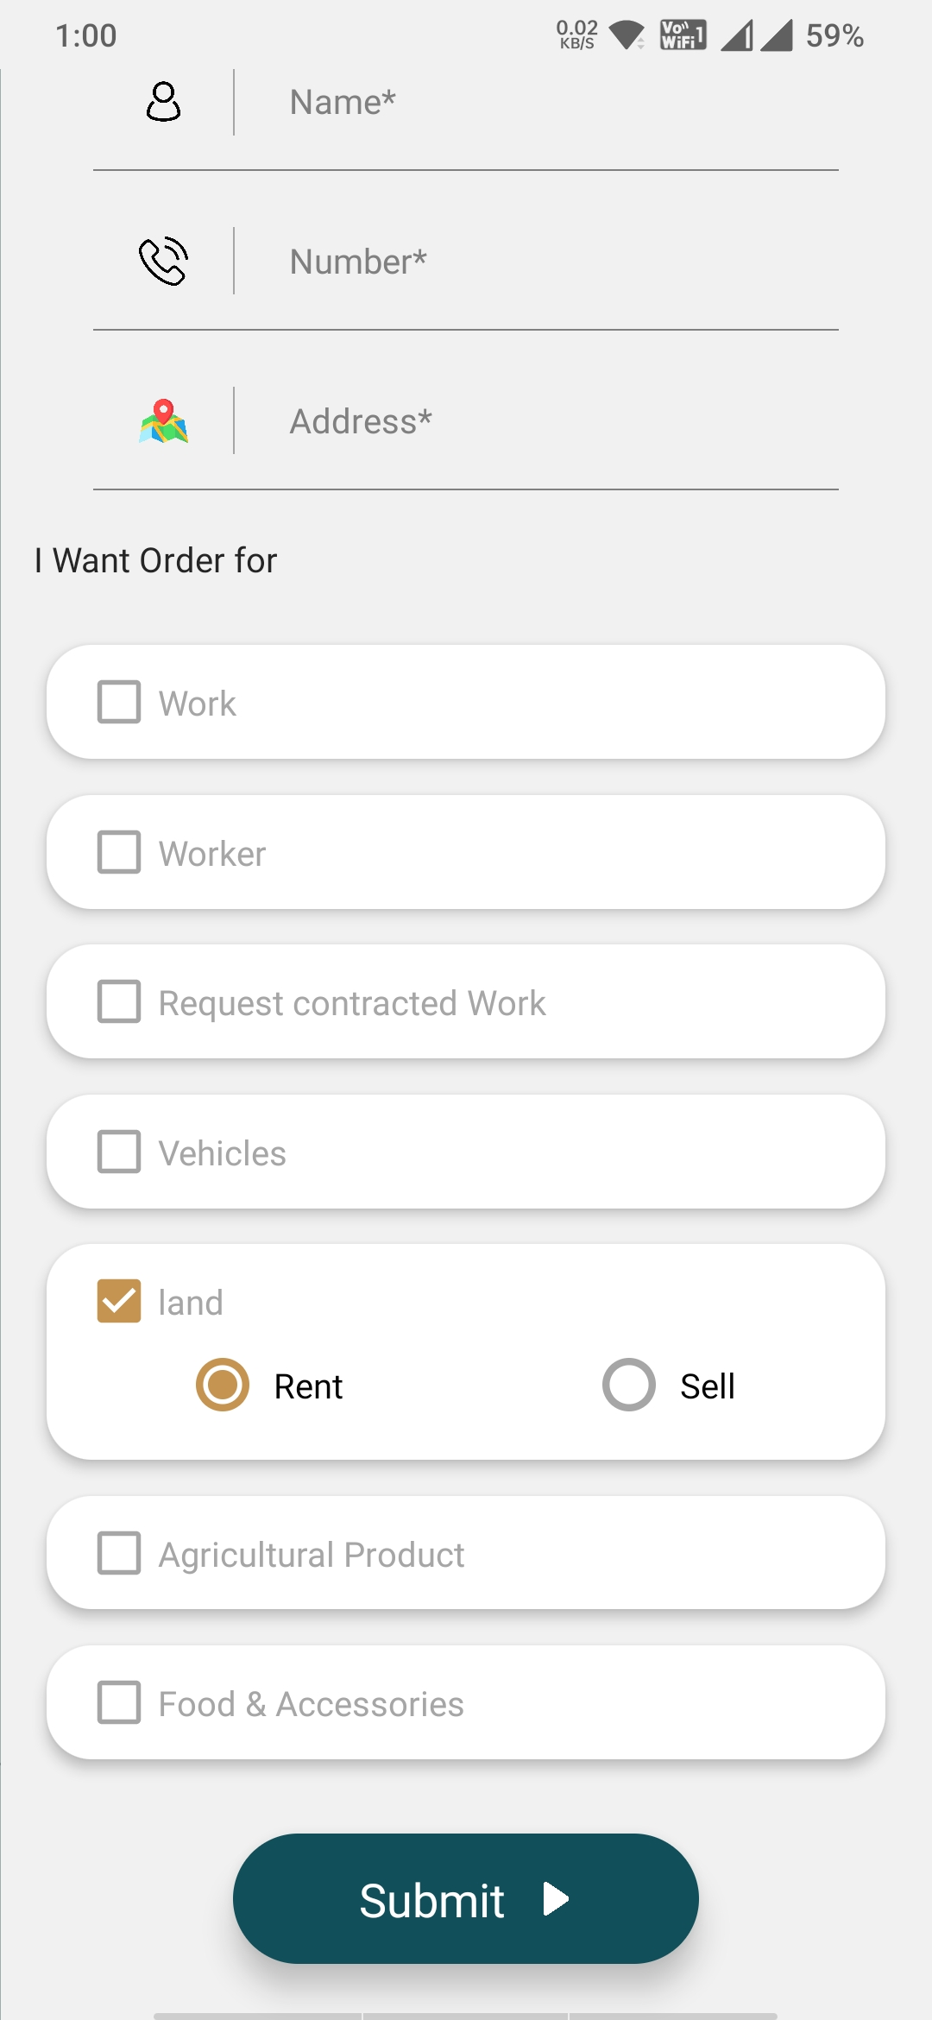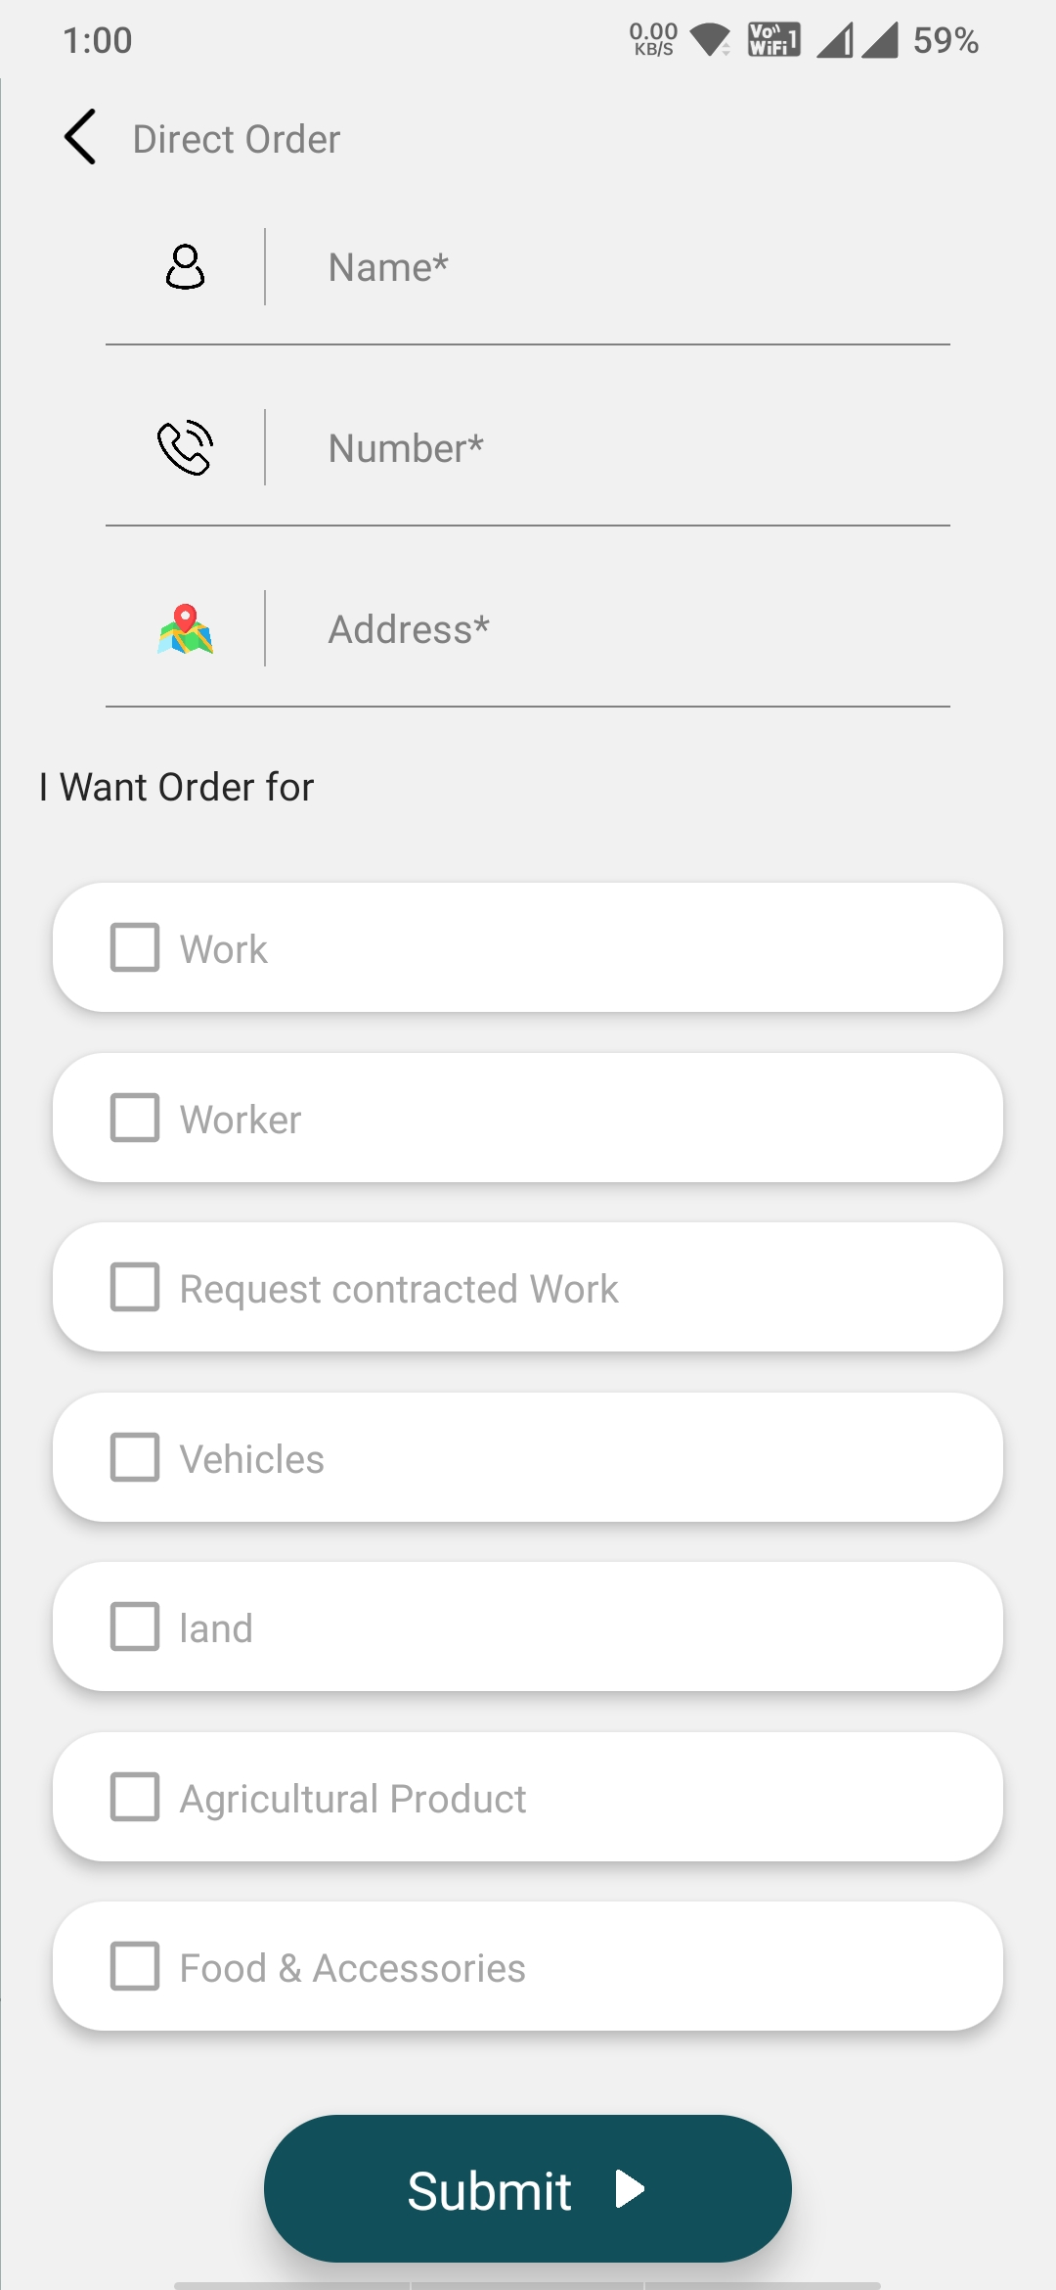

Instead of address give taluk option with dropdown of all 5 taluka in Mysuru district.

Then give option for village/ town.

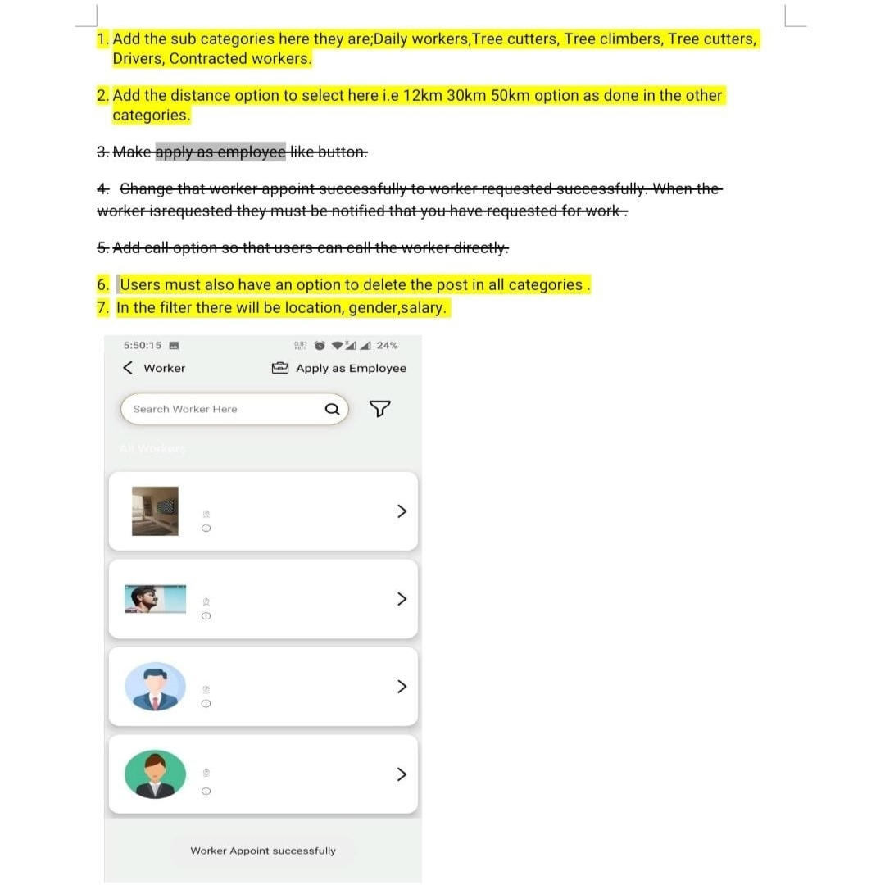

Informative option is for admin only where admin can upload videos.

Search button should be there in in informative tab and while admin uploading the video in informative tab there should be name of the video option and admin should give the name under which he is uploading videos. And users can search video in search bar with the names.

Ex : If admin is uploading video related to maize while uploading video he should enter the name of video as maize and when users type maize in search bar maize video uploaded by admin should be visible.

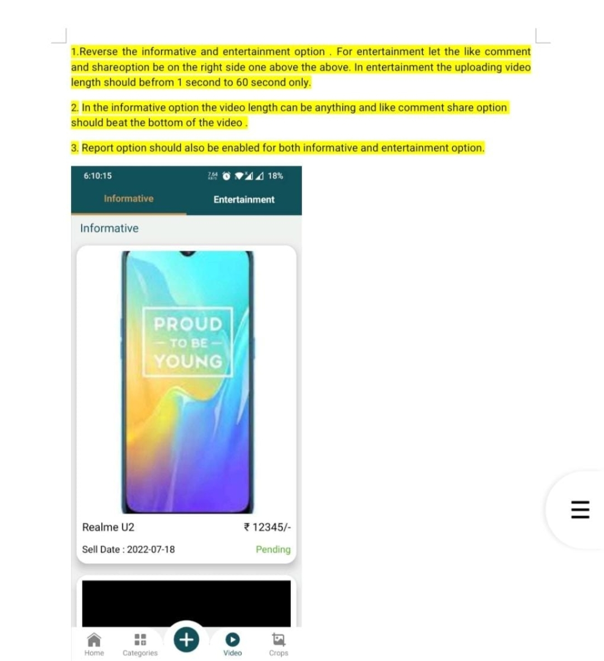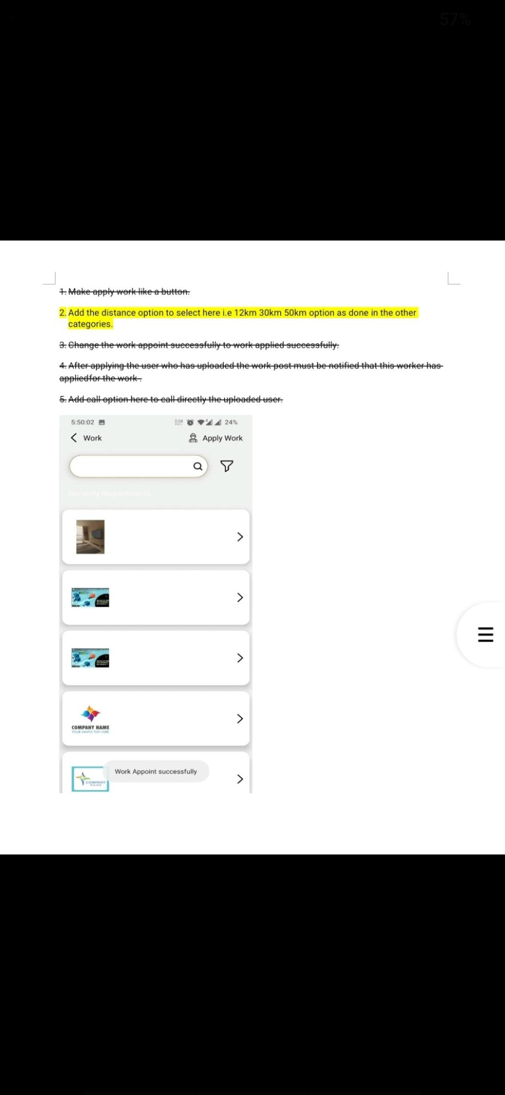

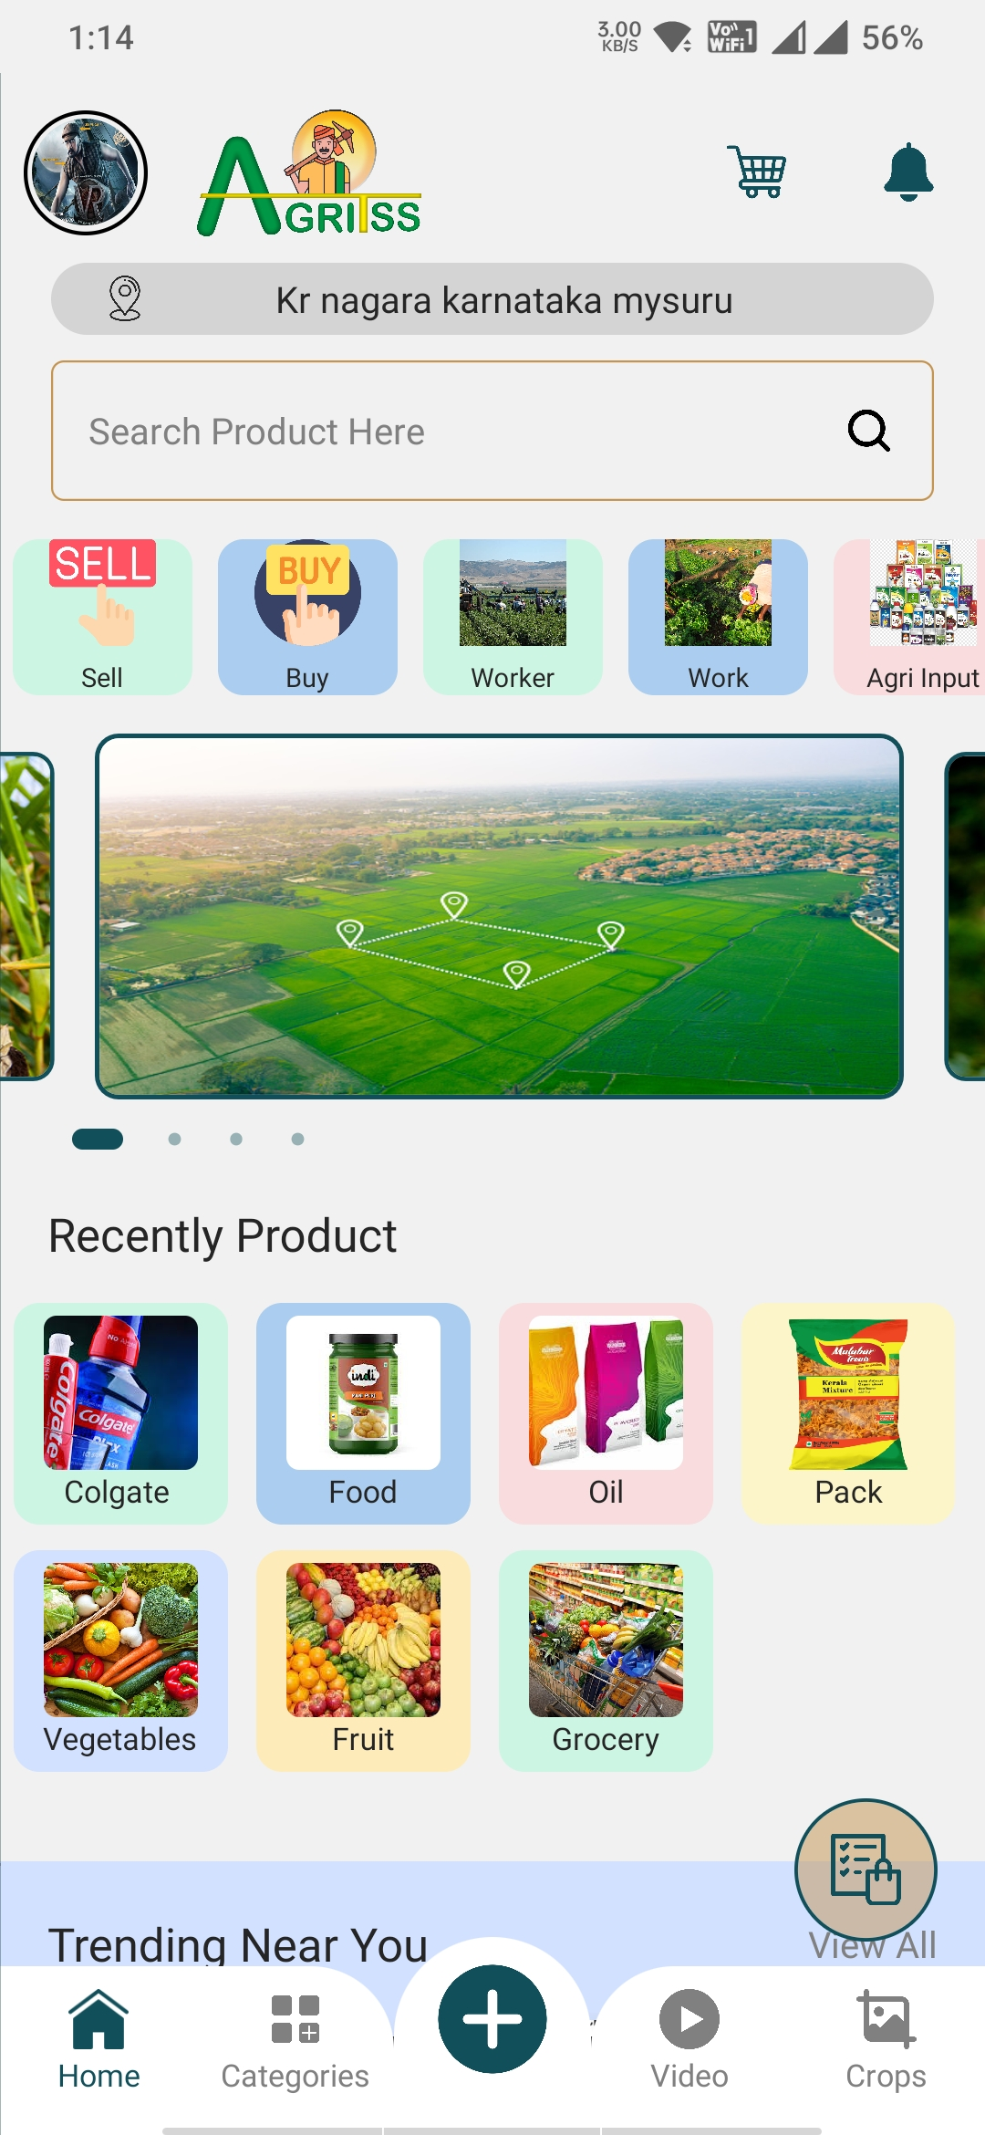

For the advertisments link option should be given for admin then when users click on the the advertisments photo it should direct them to the link

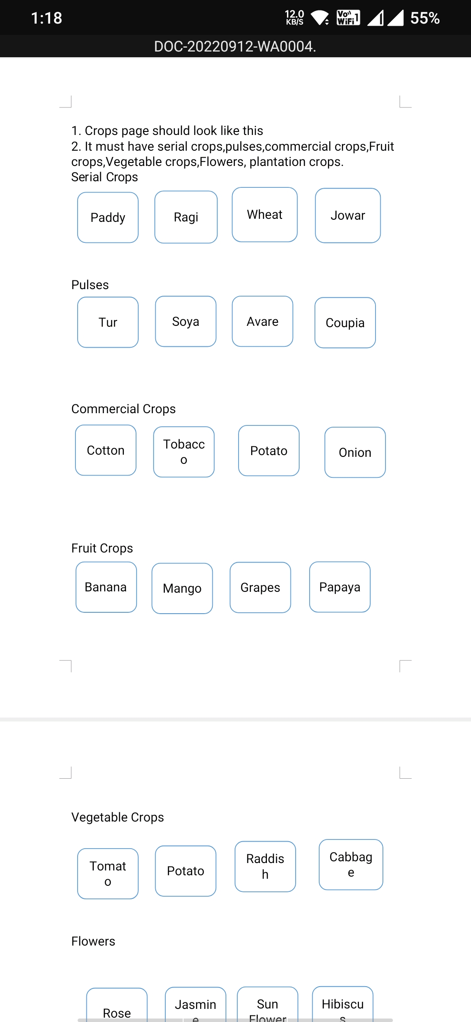

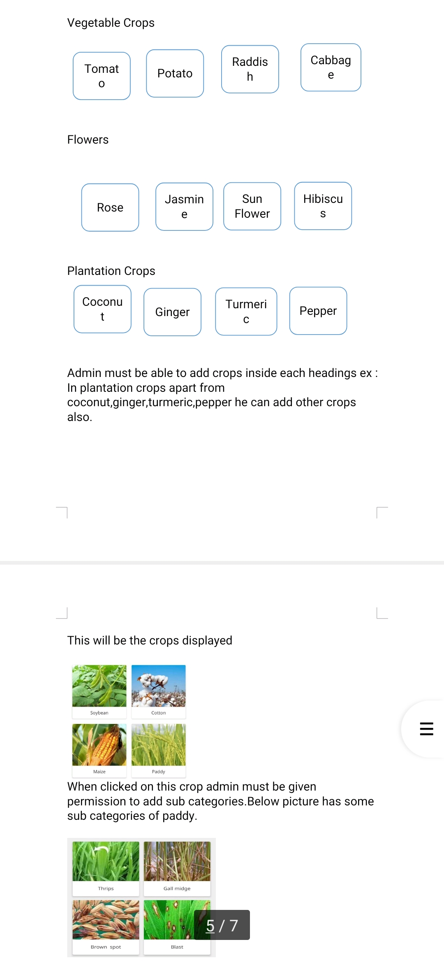

,Search bar should be enabled in crops .

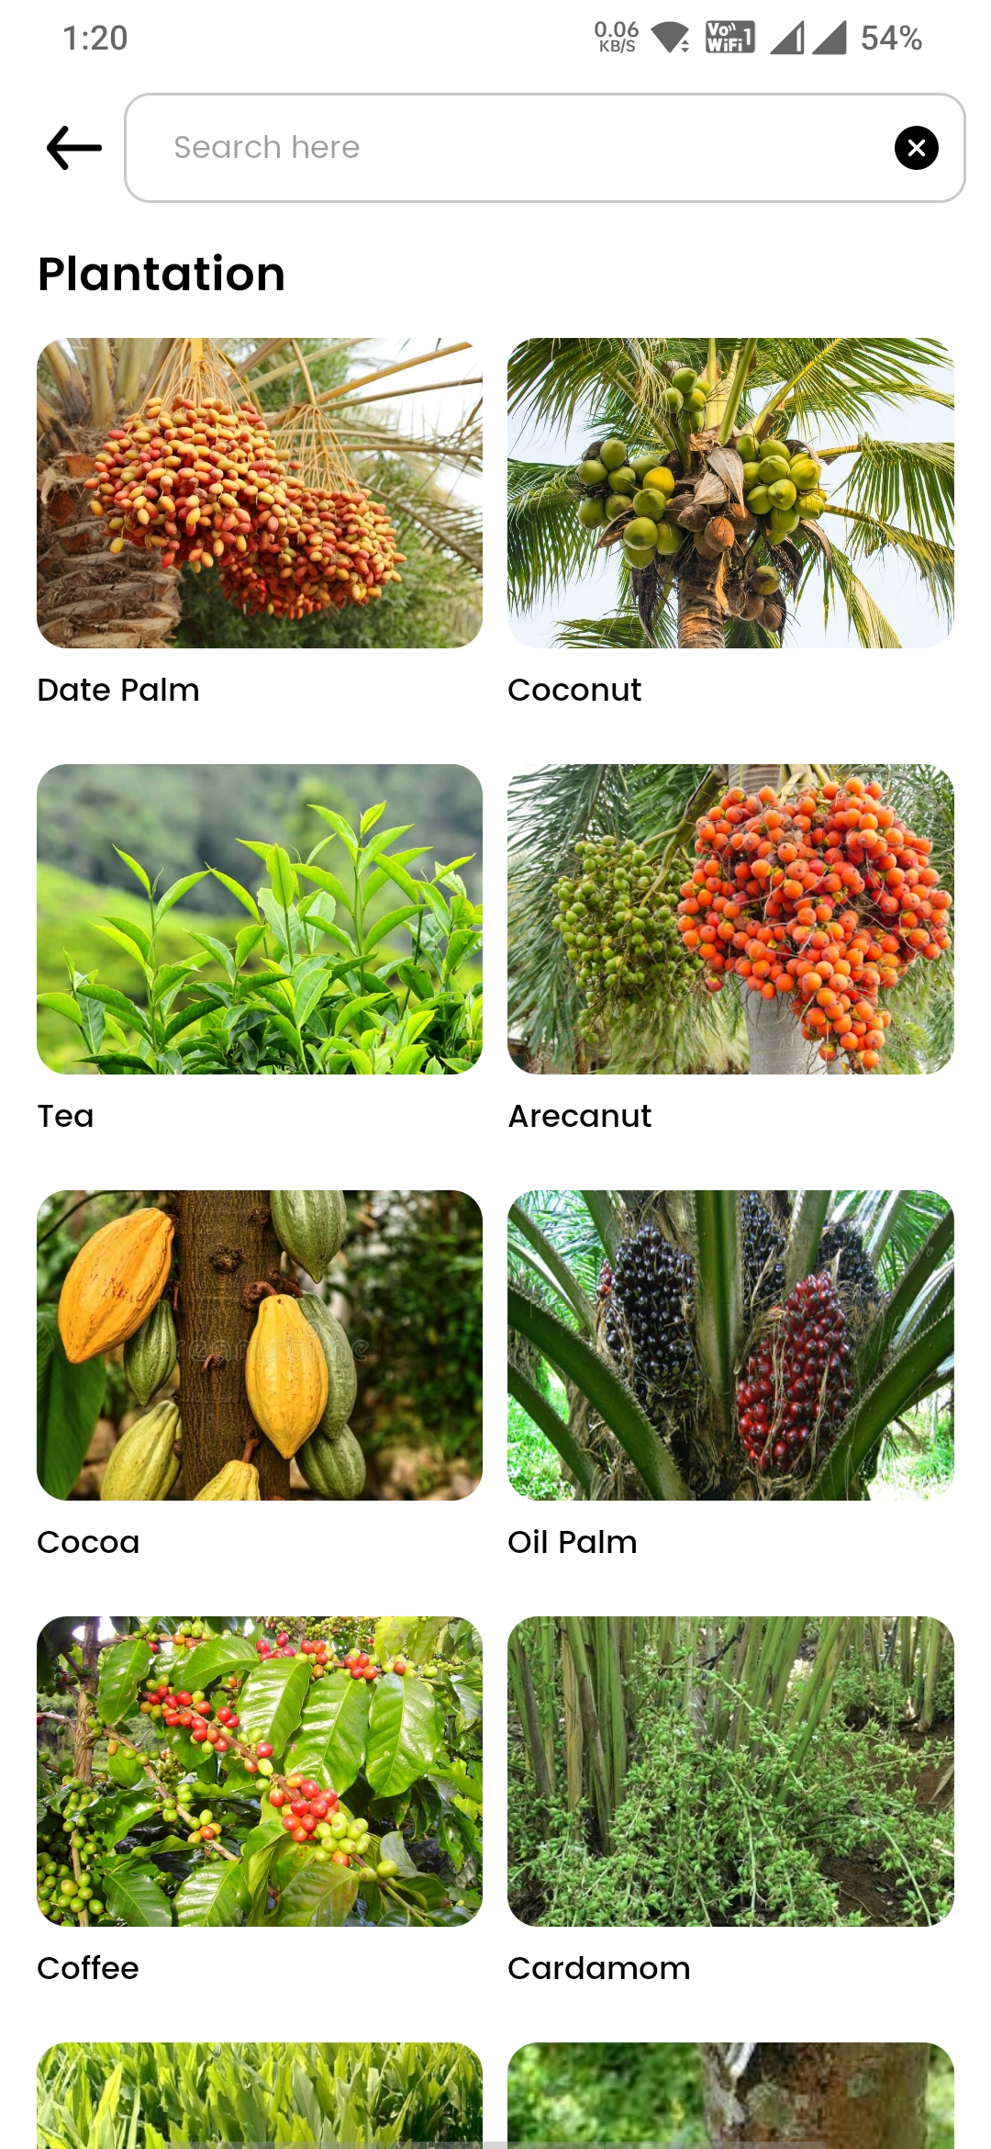

When users search crop it should direct them to the particular crop.

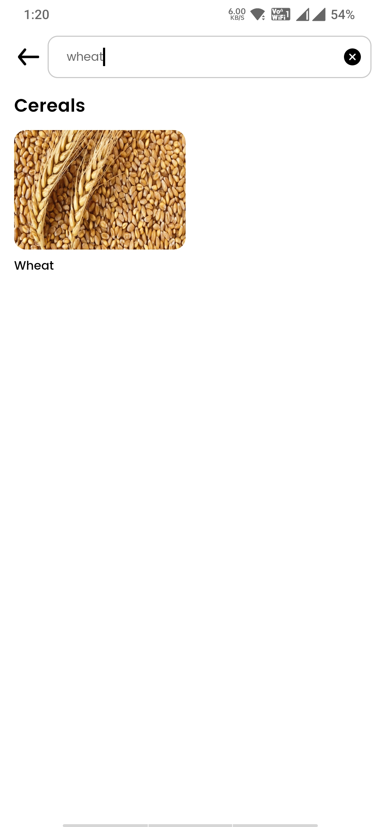

Make the date as 2 options in work

1. From date

2. To date.

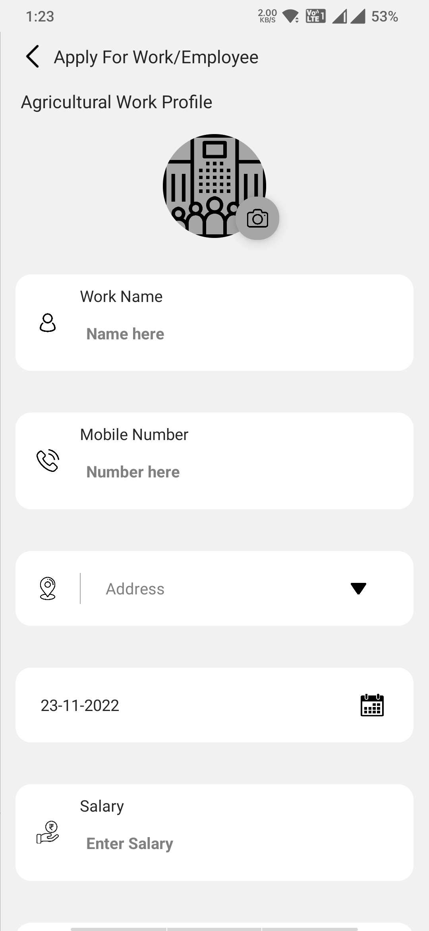

Change the form option ln this page

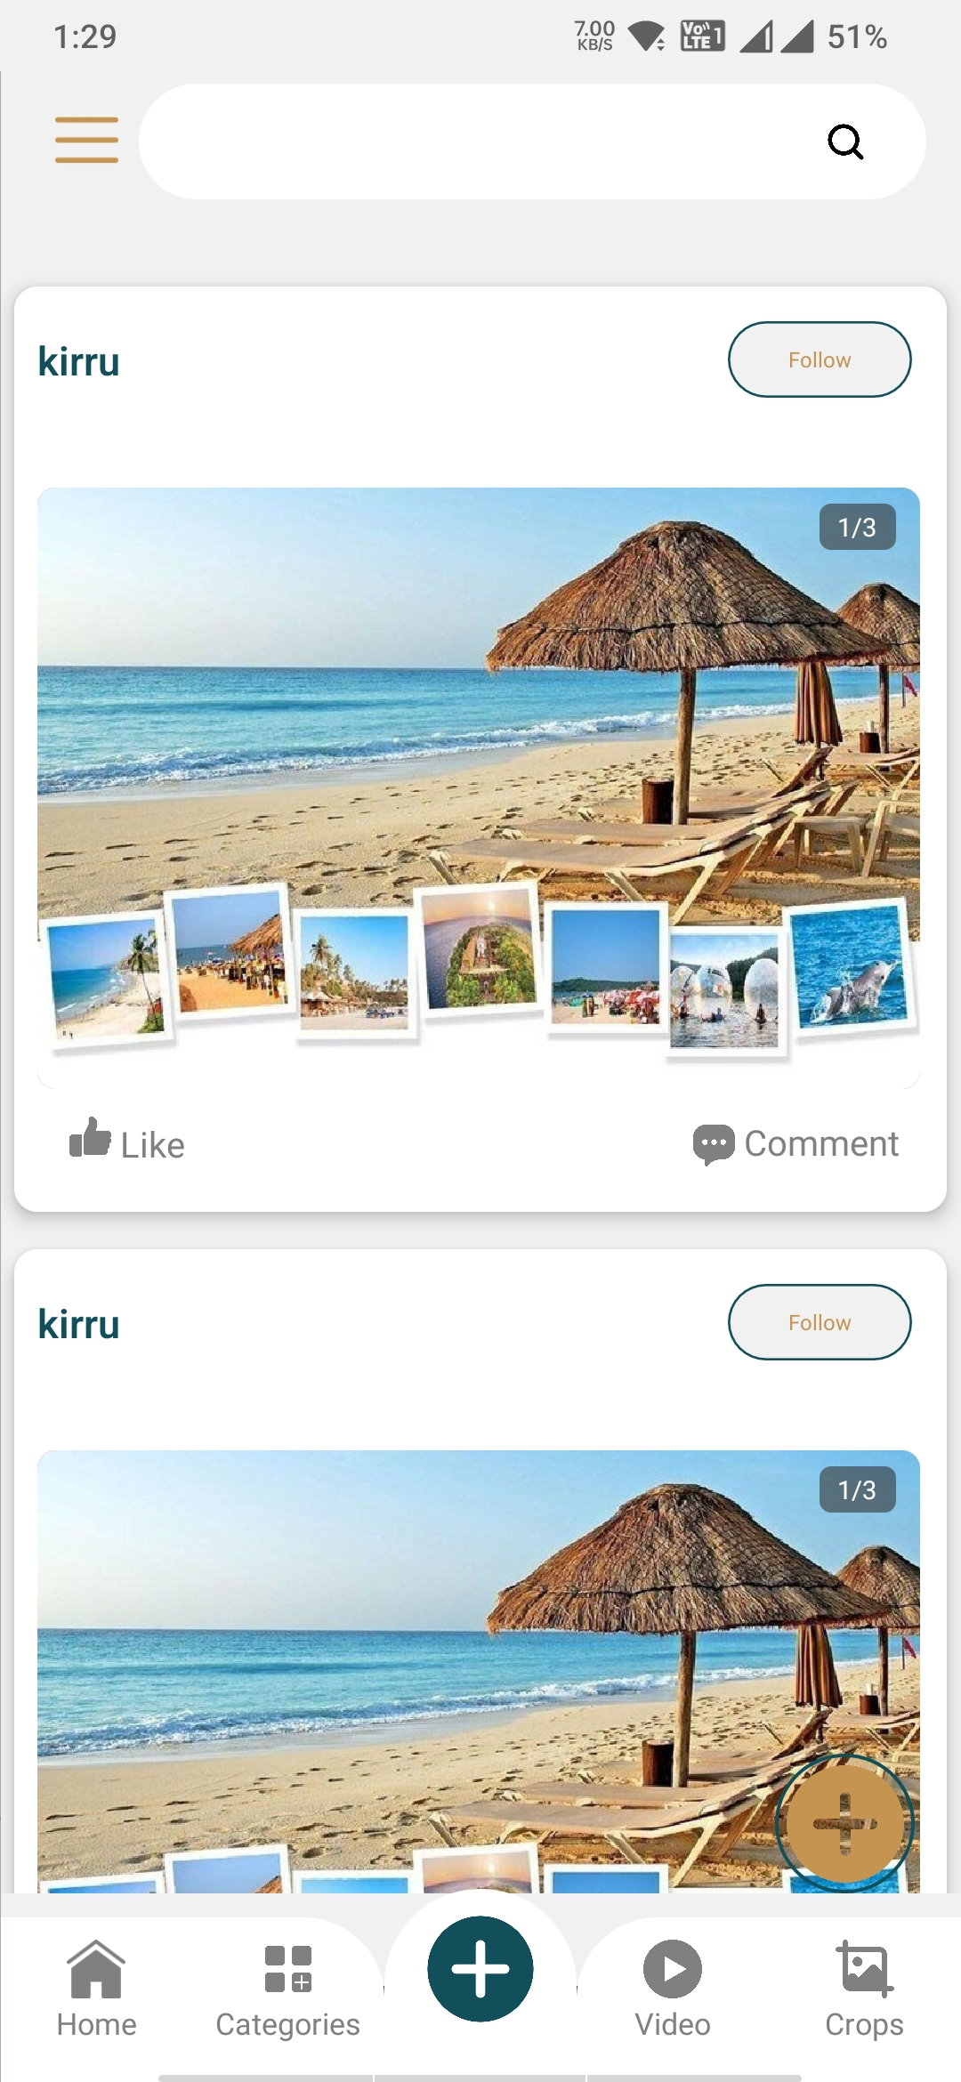

The form should be changed as following

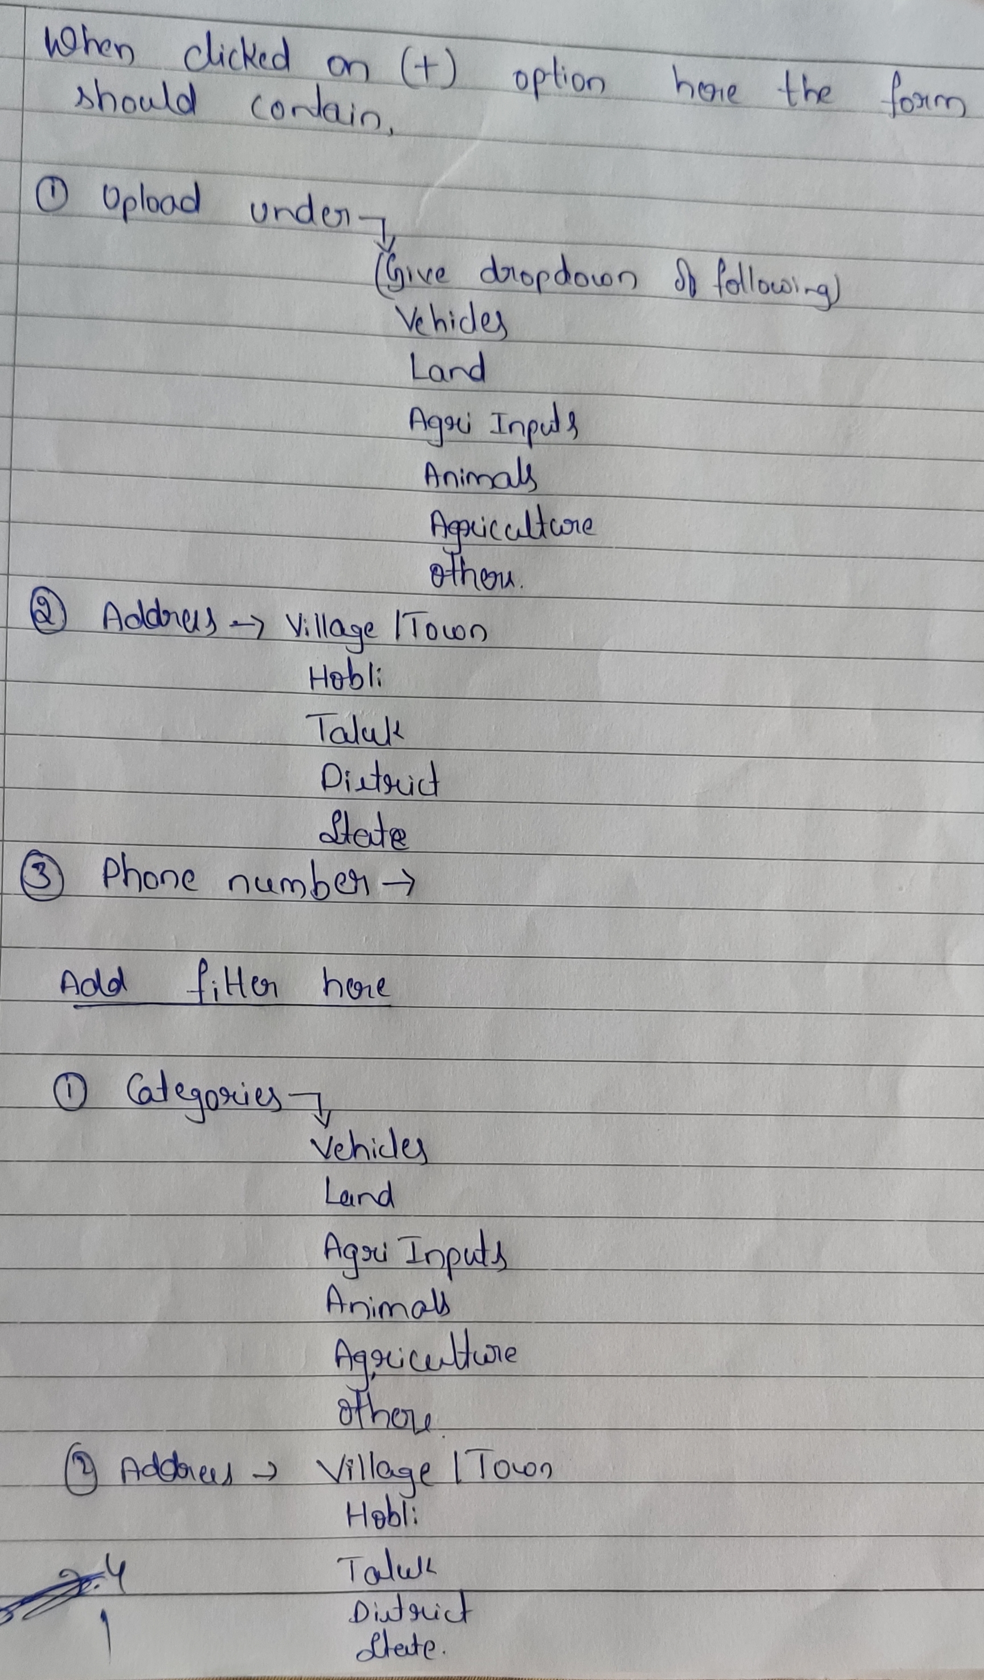

Along with form give option to add photos or write something as shown below

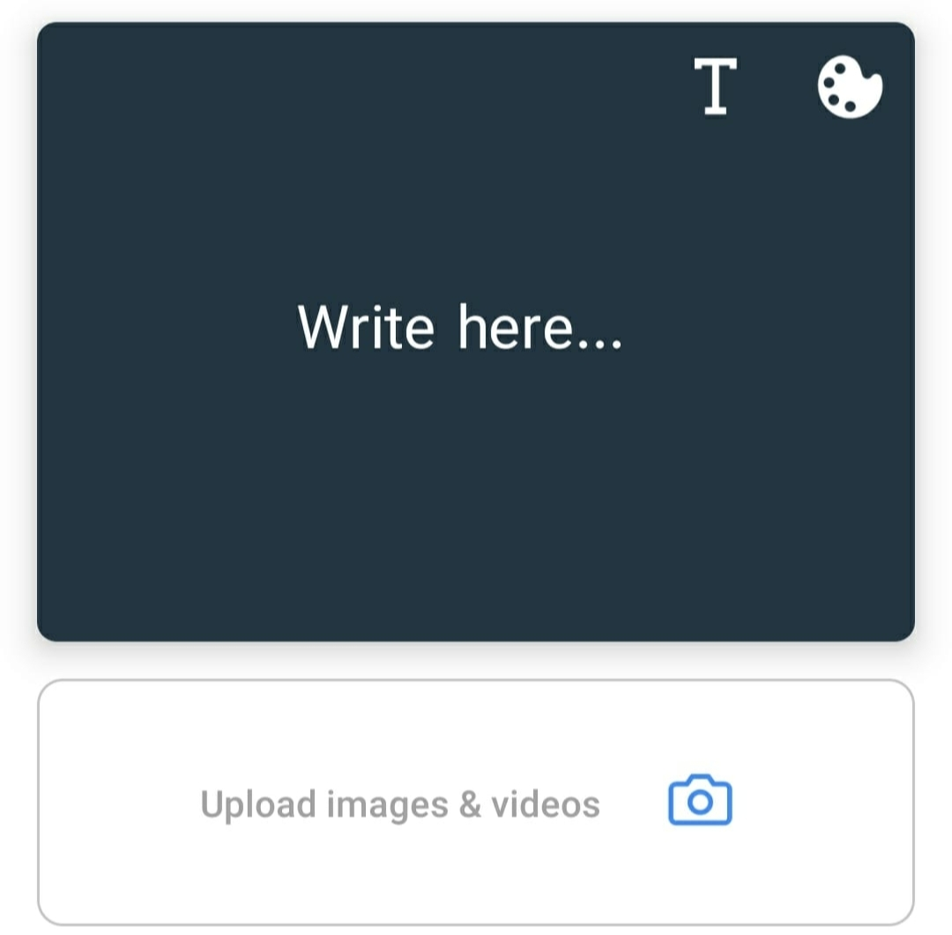

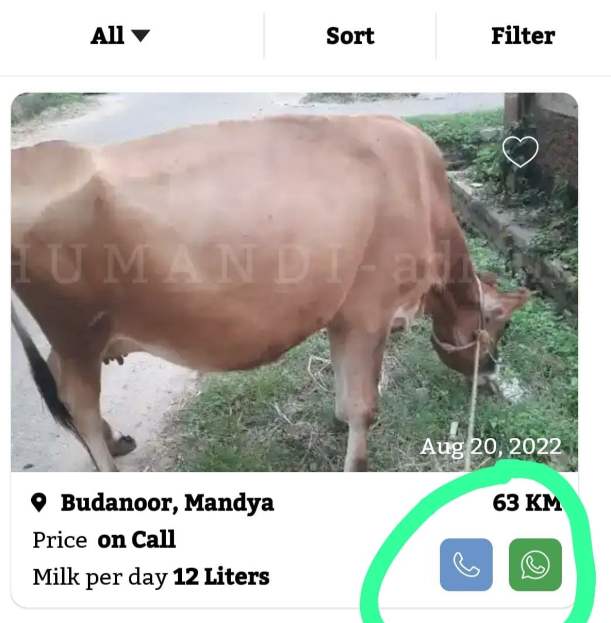

The option to call and whatsapp should be there.